**Question 0:**

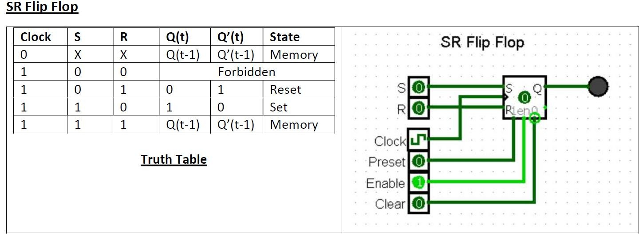

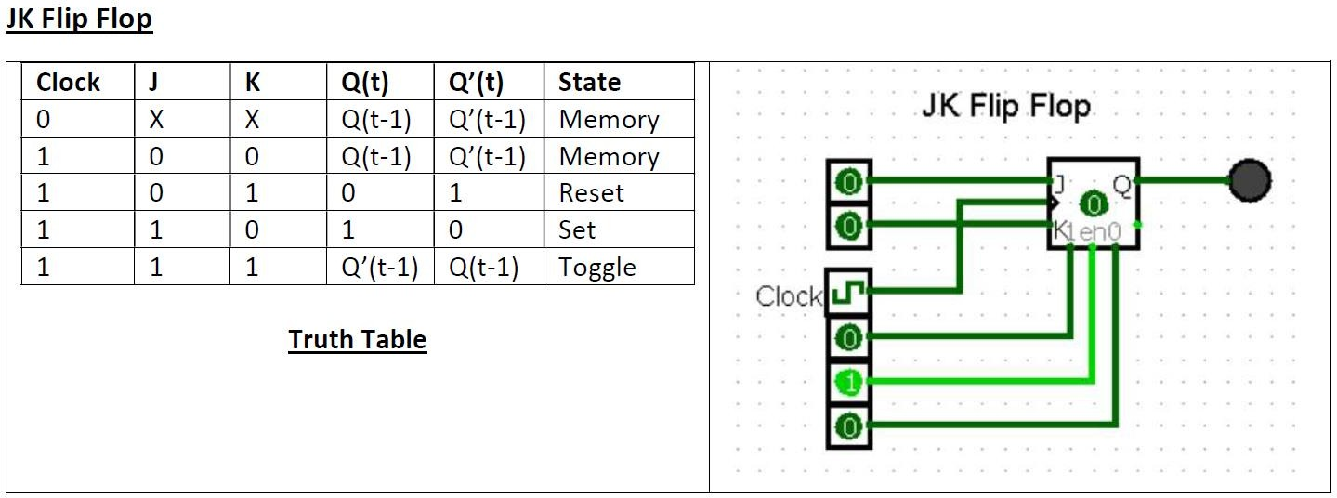

**D Flip Flop**

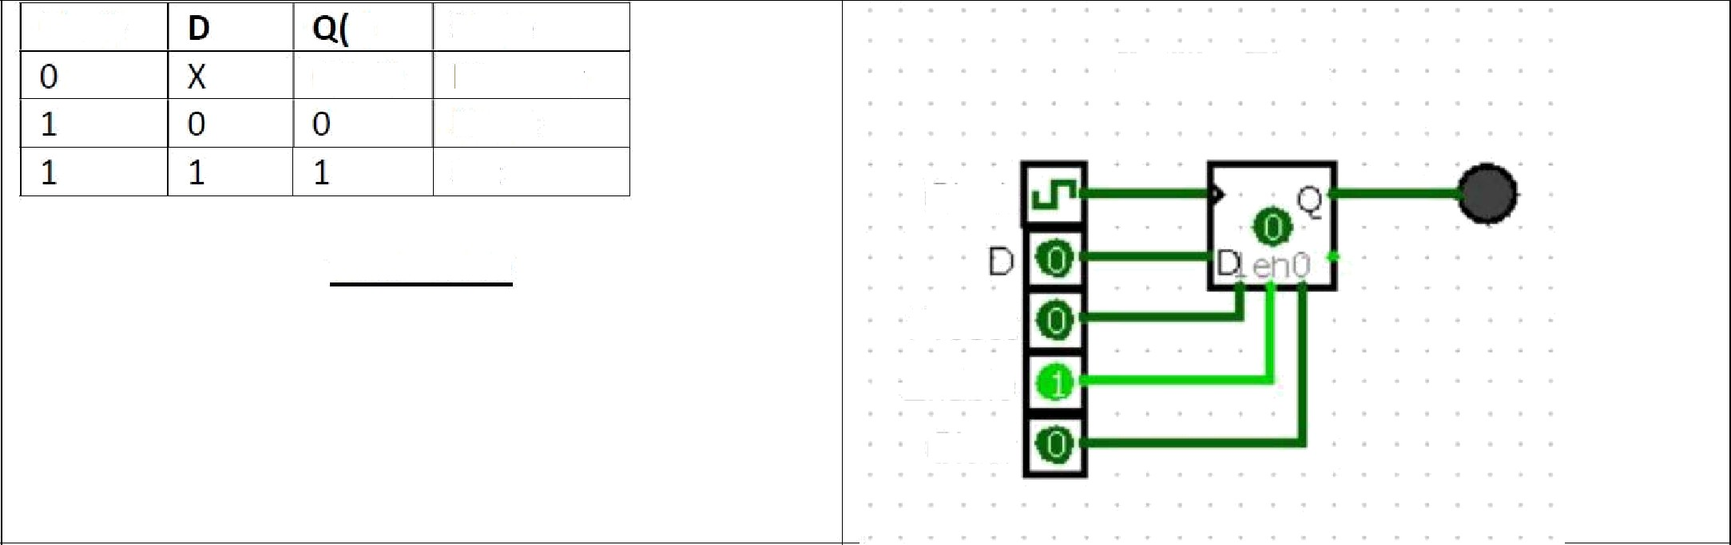

Clock

I) Q(t-1)

State Memory Reset Set

D Flip Flop

Clock

Truth Table

Preset Enable

Clear

**T Flip Flop**

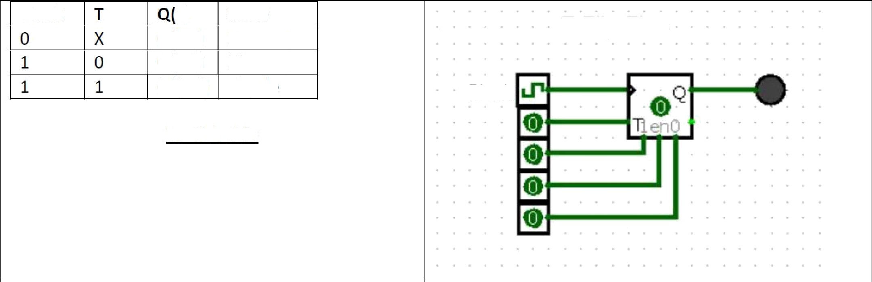

Clock

I) Q(1-1)

Q(1-1)

Q’(t-1)

State Memory Memory Toggle

T Flip Flop

Clock

Truth Table

**Question 1:**

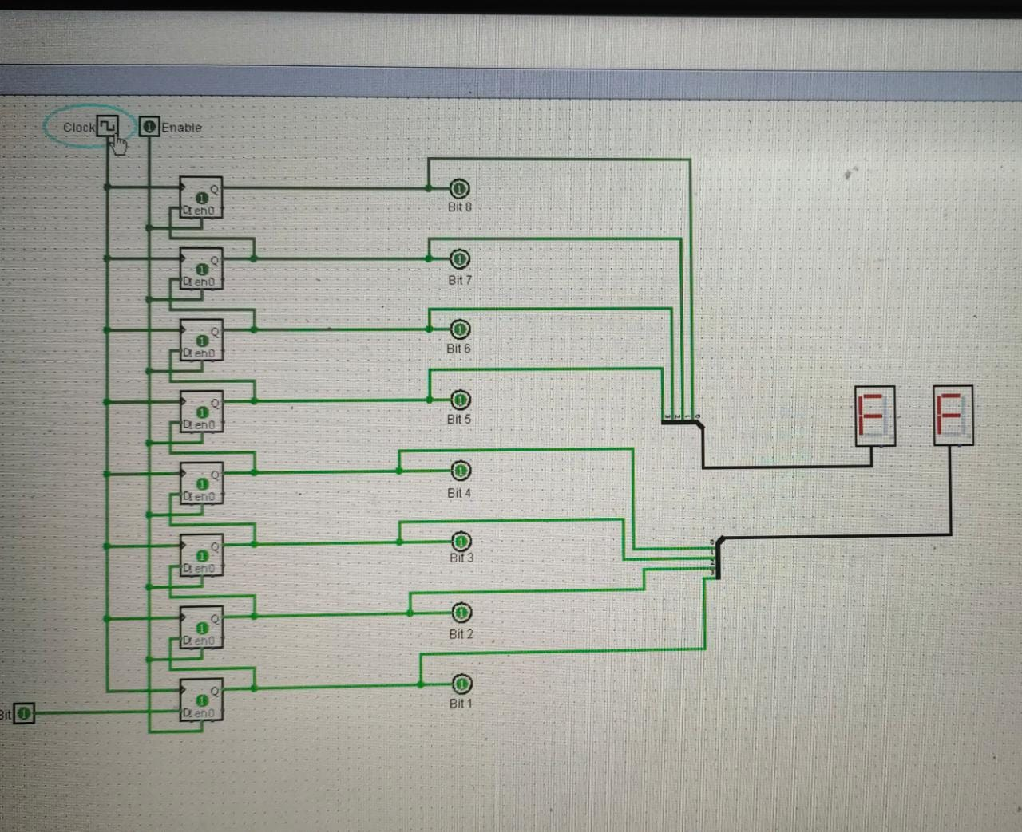

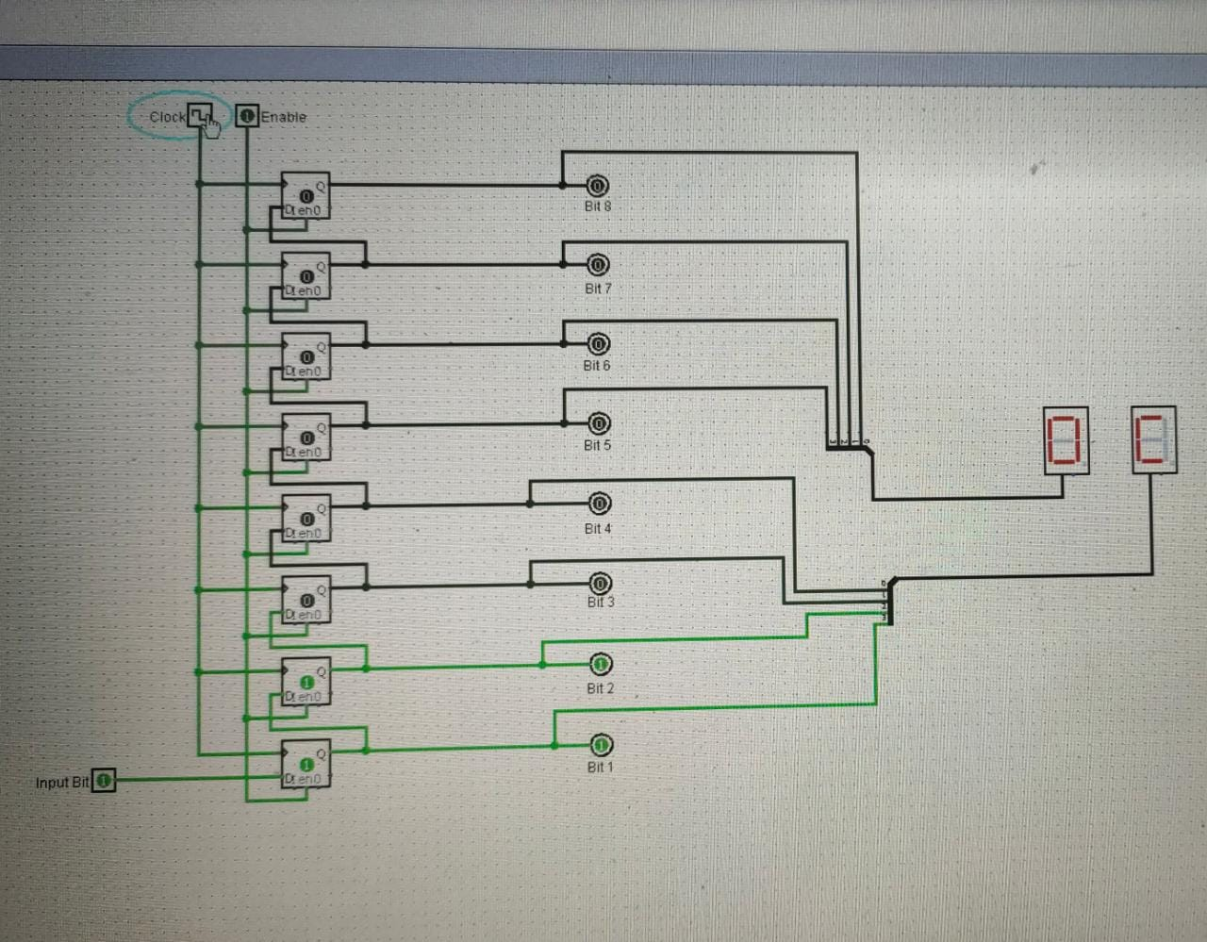

**Question 2:**

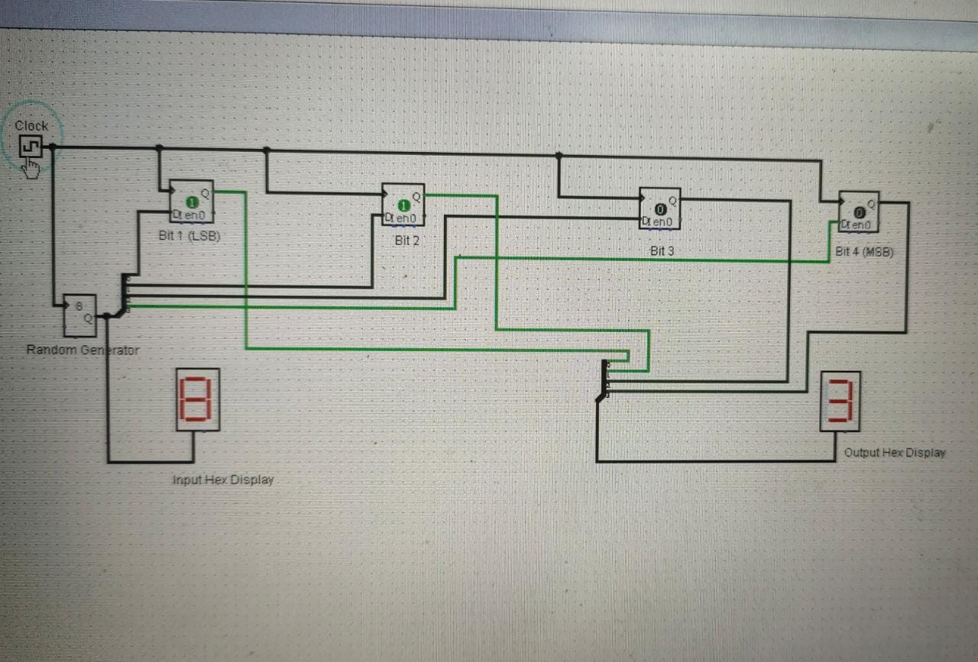

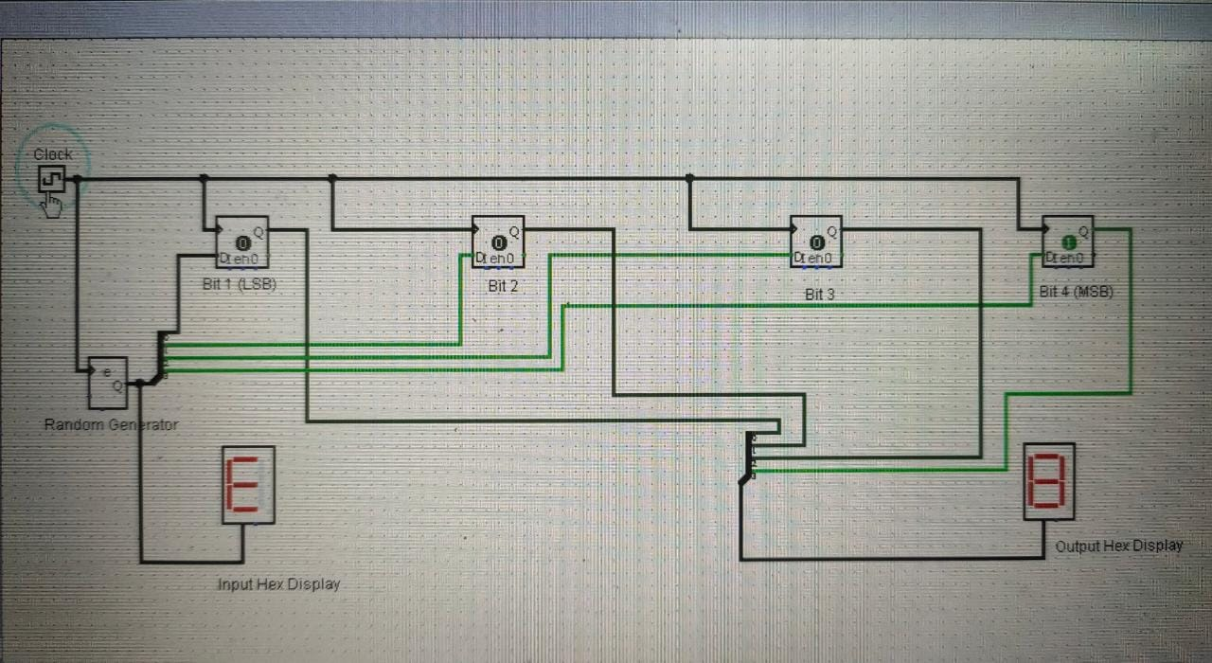

**Question 3:**

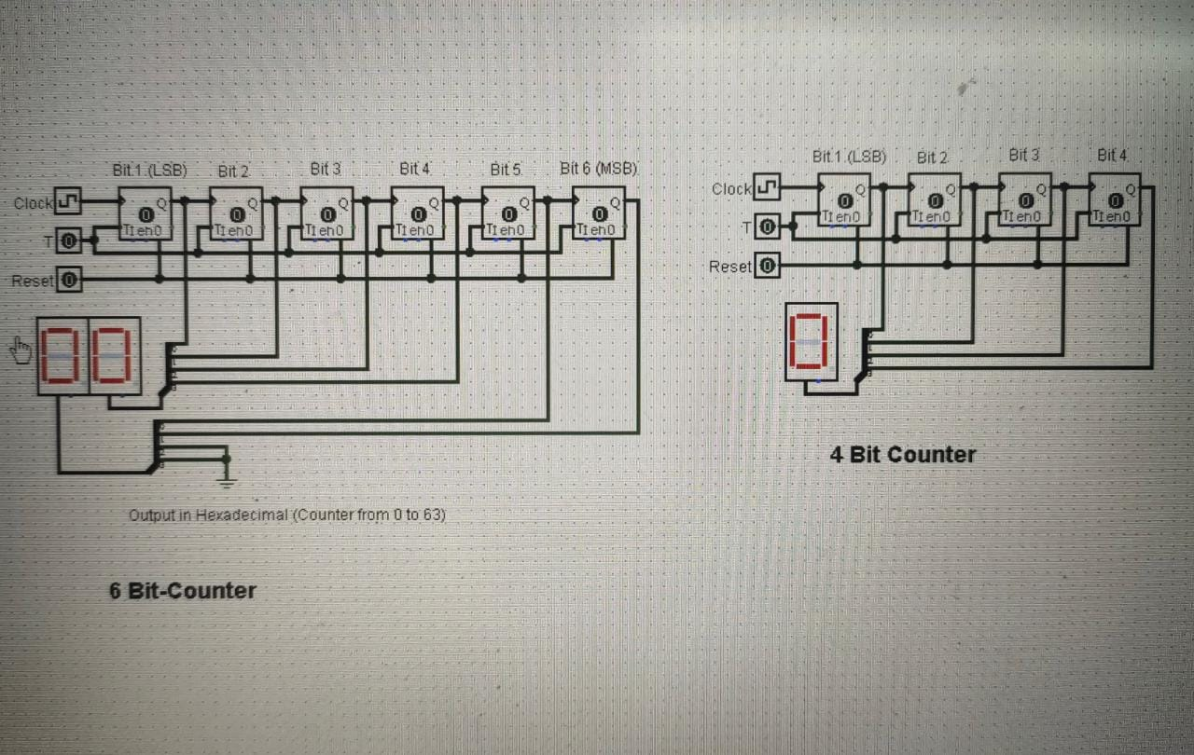

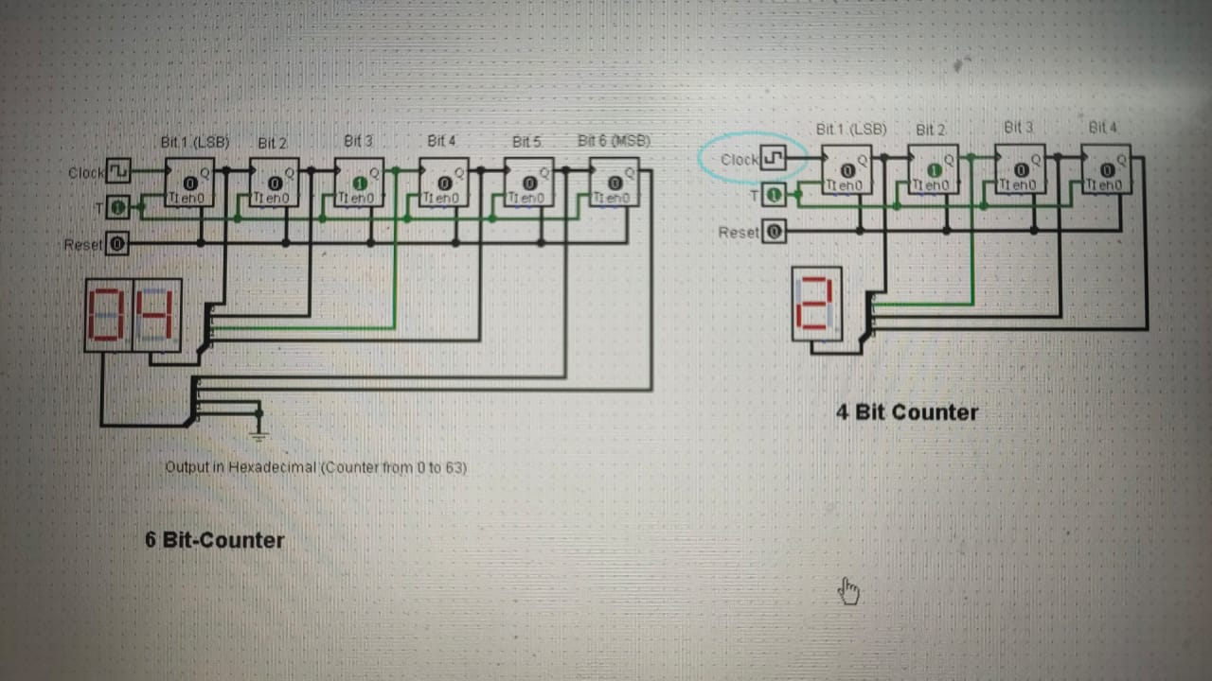

**Question 4:**

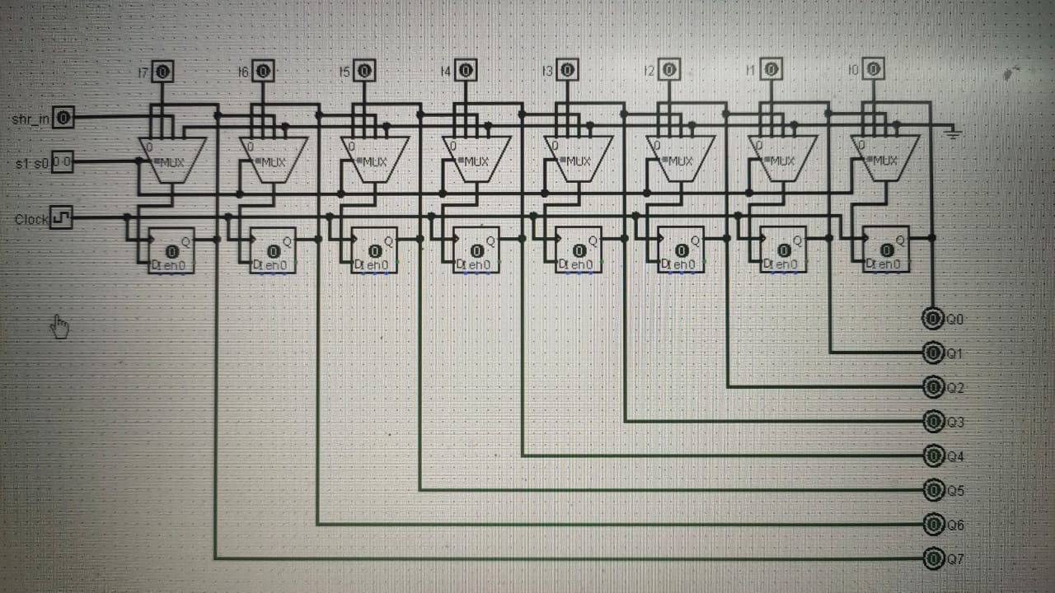

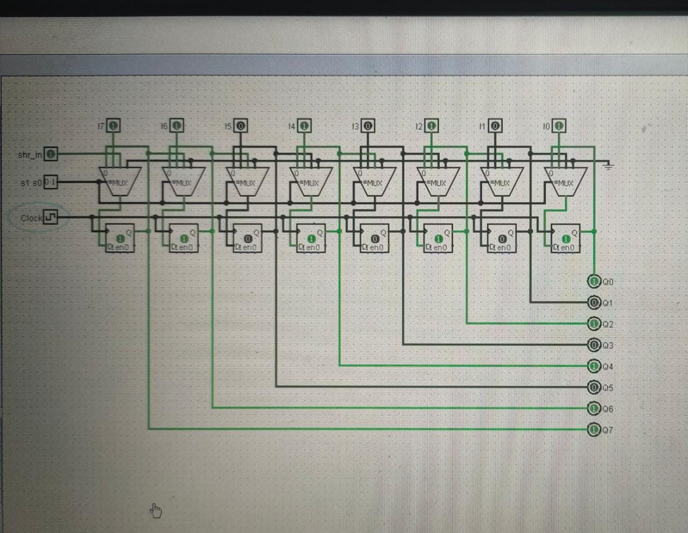

**Question 5:**



